It is possible when we use docker-compose to use the container in a detached (обособленный) mode (in a background). For example we have next yaml file:

version: "3"

services:

ngnx:

image: nginx

ports:

- 280:80

In that file we just run the container nginx in a specific port. Assume we enter command: docker-compose up -> in that case we will see

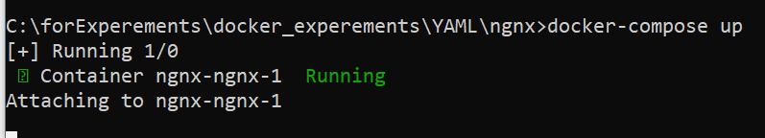

The container runs in interactive mode.

When we enter in a browser: localhost:280, we see that the container runs successfully.



Now we want to run it in a detached mode. For this we don't need to change the .yaml file, we need to provide ‘-d’ instruction when running the docker-compose.

For example:

docker-compose up -d

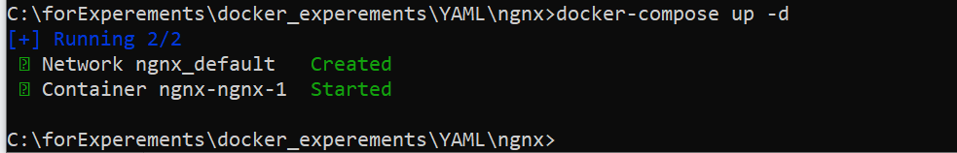

The container was created and started but it runs in a background, we are still are able to use cli. Let's check browser.



We see that container runs correctly.

To stop the container that runs in a detached mode - **docker-compose down**. It will stop only the container/containers of the .yaml file in a current directory

To show the logs that produce the container being run - **docker-compose logs**

There is one trick in that instruction. For example being in directory of someFile.yaml and if you use the docker-compose logs it will show you the logs of the container that was run from the someFile.yaml in that specific directory. If you have multiple containers run at one time and want to see specific container logs you can change the directory where the desired .yaml file of that container is. Or docker-compose logs <name_of_the_server> - it is pretty trecky since we can not get the name of the service from command docker ps, because it gives us containers names that were produced automatically and has nothing to do with actual servers names that are indicated in a .yaml file, the same is for the id of containers - it doesn't work. Only the name of the server indicated in .yaml file works.